Lecture # 23:

Objective:

* FILE STREAMING
  + LOG FILE EXAMPLE

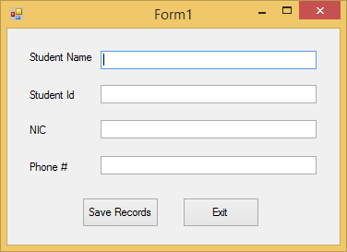

using System;

using System.Collections.Generic; using System.ComponentModel; using System.Data;

using System.Drawing; using System.Linq; using System.Text;

using System.Windows.Forms; using System.IO;

namespace logfiles

{

public partial class Form1 : Form

{

public Form1()

{

InitializeComponent();

}

private void textBox2_TextChanged(object sender, EventArgs e)

{

}

private void btnexit_Click(object sender, EventArgs e)

{

Application.Exit();

}

private void btnsave_Click(object sender, EventArgs e)

{

try

{

if (textname.Text.Contains("1") ||

textname.Text.Contains("2") || textname.Text.Contains("3") || textname.Text.Contains("4") || textname.Text.Contains("5") || textname.Text.Contains("6") || textname.Text.Contains("7") || textname.Text.Contains("8") || textname.Text.Contains("9"))

{

throw new Exception("Invalid Name");

}

int ehID = int.Parse(textid.Text);

double ehph = double.Parse(textphon.Text); double ehNIC = double.Parse(textnic.Text);

}

catch (Exception ex)

{

FileStream f = new FileStream("c:\\elog.txt", FileMode.Append, FileAccess.Write);

StreamWriter sw = new StreamWriter(f);

string msg = DateTime.Now + "," + ex.Message + "," +

this.Text + ";";

}

sw.WriteLine(msg); sw.Close();

}

}

}

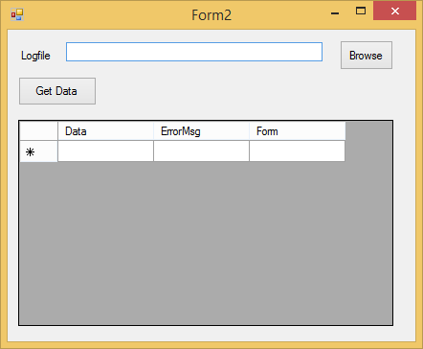

using System;

using System.Collections.Generic; using System.ComponentModel; using System.Data;

using System.Drawing; using System.Linq; using System.Text;

using System.Windows.Forms; using System.IO;

namespace logfiles

{

public partial class Form2 : Form

{

public Form2()

{

InitializeComponent();

}

private void btnbrows_Click(object sender, EventArgs e)

{

DialogResult dr = openFileDialog1.ShowDialog(); if (dr == DialogResult.OK)

{

textBox1.Text = openFileDialog1.FileName;

}

}

private void btndata_Click(object sender, EventArgs e)

{

FileStream f = new FileStream(textBox1.Text, FileMode.Open, FileAccess.Read);

StreamReader sr = new StreamReader(f); string data = sr.ReadToEnd(); sr.Close();

f.Close();

string[] lineWiseRecord = data.Split(';'); foreach (string item in lineWiseRecord)

{

string[] colWiseRecord = item.Split(','); dataGridView1.Rows.Add(colWiseRecord[0],

colWiseRecord[1], colWiseRecord[2]);

}

}

}

}